FOR IMMEDIATE RELEASE

Legends League Cricket Announces Schedule for 2023 season, India Capitals To Face Bhilwara Kings In The Opening Match On Nov 18

PayTm and PayTm Insider to be the Exclusive Ticketing Partner

Overall, 19 matches will be played across 22 days in what promises to be high voltage tournament as Legends unite to define sheer class in the LLC 2023

New Delhi, October 21, 2023: Legends League Cricket (LLC) on Saturday announced the complete schedule and fixtures for the highly anticipated upcoming 2023 season which is to be played across five cities in India from November 18 to December 9, 2023. In addition to this exciting fixture announcement, Legends League Cricket (LLC) is proud to announce PayTm and PayTm Insider as the Exclusive Ticketing Partner for LLC 2023. Tickets for the tournament will be available for purchase on PayTm and PayTm Insider soon, providing fans with the opportunity to secure their seats for this thrilling season of cricket.

This year's Legends League Cricket will be a six-team tournament and will be played across five cities in India – Ranchi, Dehradun, Jammu, Vizag, and Surat.

The inaugural match of LLC 2023 is scheduled to kick off on November 18 in Ranchi, where the India Capitals will take on the Bhilwara Kings. This game promises to be a thrilling encounter, as it is a replay of the 2022 final, where India Capitals had defeated Bhilwara Kings by 104 runs to lift the coveted trophy.

Overall, 19 matches will be played across 22 days in what promises to be a exciting tournament as Legends unite to define sheer class in the LLC 2023.
After Ranchi, the action will shift to Dehradun on November 24, with the Bhilwara Kings clashing with the Gujarat Giants in what will be the sixth match of the season.

In Jammu, four matches will be played from November 27 to December 1 while in Vizag three games will be staged from December 2 to December 4.

The knockout phase of LLC 2023 will be played in Surat, with the semi-finals taking place on December 5 and December 6, setting the stage for the grand season finale, which is scheduled for December 9.

Raman Raheja, Co-Founder & CEO, Legends League Cricket said, "Legends League Cricket last season was a huge success, and we are ready to entertain the fans in the upcoming season. With the games being played at Ranchi, Dehradun, Jammu, Vizag, and Surat, we are not just hosting a tournament; we are spreading the love for the game far and wide in the country. We partnered with PayTm and PayTm Insider which has a wider customer base and reach for the ticket sales as well, which will help us bring more fans to the stadium.”

Former Indian cricketer Suresh Raina will captain the new franchise Urbanrisers Hyderabad in LLC. The second new franchise this season announced by LLC is the Southern Super Stars. It will be captained by former Australia skipper Aaron Finch.

The first match of the tournament will see former Indian cricketers Gautam Gambhir (India Capitals) and Irfan Pathan (Bhilwara Kings) facing each other as captains on November 18.

Full Schedule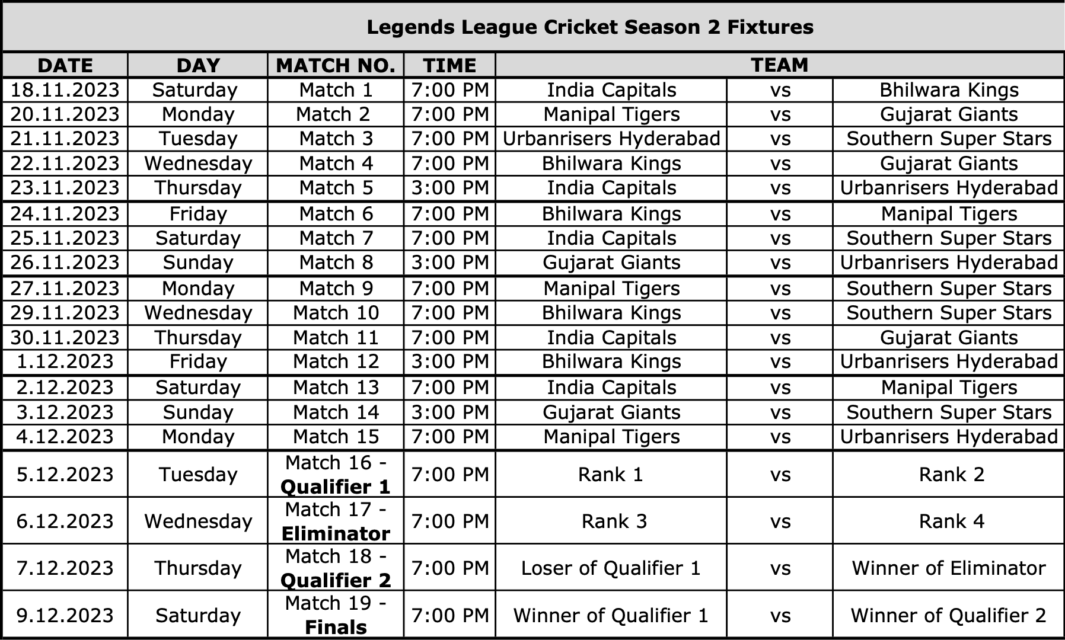
Team Squads
Bhilwara Kings | Gujarat Giants | India Capitals | Manipal Tigers | Southern Super Stars | Urbanrisers Hyderabad
Irfan Pathan (c) | Parthiv Patel (c) | Gautam Gambhir (c) | Harbhajan Singh (c) | Aaron Finch (c) | Suresh Raina (c)
Yusuf Pathan | Chris Gayle | Pravin Tambe | Mohammad Kaif | Upul Tharanga | Martin Guptil
Shane Watson | Kevin O'Brien | Ashley Nurse | Corey Anderson | Abdur Razzak | Dwanye Smith
Ryan Sidebottom | Elton Chigumbura | Morne van Wyk | Thisara Perera | Jesse Ryder | Peter Trego
Iqbal Abdulla | Richard Levi | Rusty Theron | Robin Uthappa | Cameron White | Chamara Kapugedera
Pinal Shah | Liam Plunkett | Ben Robert Dunk | Hamilton Masakadza | Suranga Lakmal | Morne Morkel
William Porterfield | Seekkuge Prasanna | Ricardo Powell | David White | Manvinder Bisla | Stuart Binny
Tim Murtagh | S. Sreesanth | Fidel Edwards | Amitoze Singh | Ashok Dinda | Asghar Afghan
Christopher Barnwell | Sarabjit Ladda | Dilhara Fernando | Pankaj Singh | Bipul Sharma | Tino Best
Anureet Singh | Dishant Yagnik | Kirk Edwards | Colin de Grandhomme | Andre McCarthy | Amit Paunikar
Jesal Karia | Dane Piedt | Ishwar Pandey | Chadwick Walton | Rameez Khan | Mohnish Mishra
Solomon Mire | Sulieman Benn | Hashim Amla | Mitchell McClenaghan | Amila Aponso | Christopher Mpofu
Lendl Simmons | Nathan Reardon | Kevin Pietersen | Parvinder Awana | Pankaj Kumar Rao | Pawan Suyal
Dhammika Prasad | Rayad Ryan Emrit | K P Appanna | Pravin Gupta | Rajesh Bishnoi | Jerome Taylor
Prosper Utseya | Ahmed Raza | Munaf Patel | Kyle Coetzer | Amit Verma | Sudeep Tyagi
Rahul Sharma | Abhishek Jhunjhunwala | Yalaka Gnaneswara Rao | S. Badrinath | Tanmay Srivastava | Yogesh Nagar
Tilakaratne Dilshan | Chirag Khurana | Yashpal Singh | Imran Khan | Farveez Maharoof | Shivakant Shukla
 | Ben Laughlin | Bharat Chipli | Praveen Kumar | Ross Taylor | Pragyan Ojha
 | Abhimanyu Mithun |  |  | Johan Botha | Devendra Bishoo
 |  |  |  | Shreevats Goswami | Tirumalasetti Suman
 |  |  |  |  | Milind Kumar

