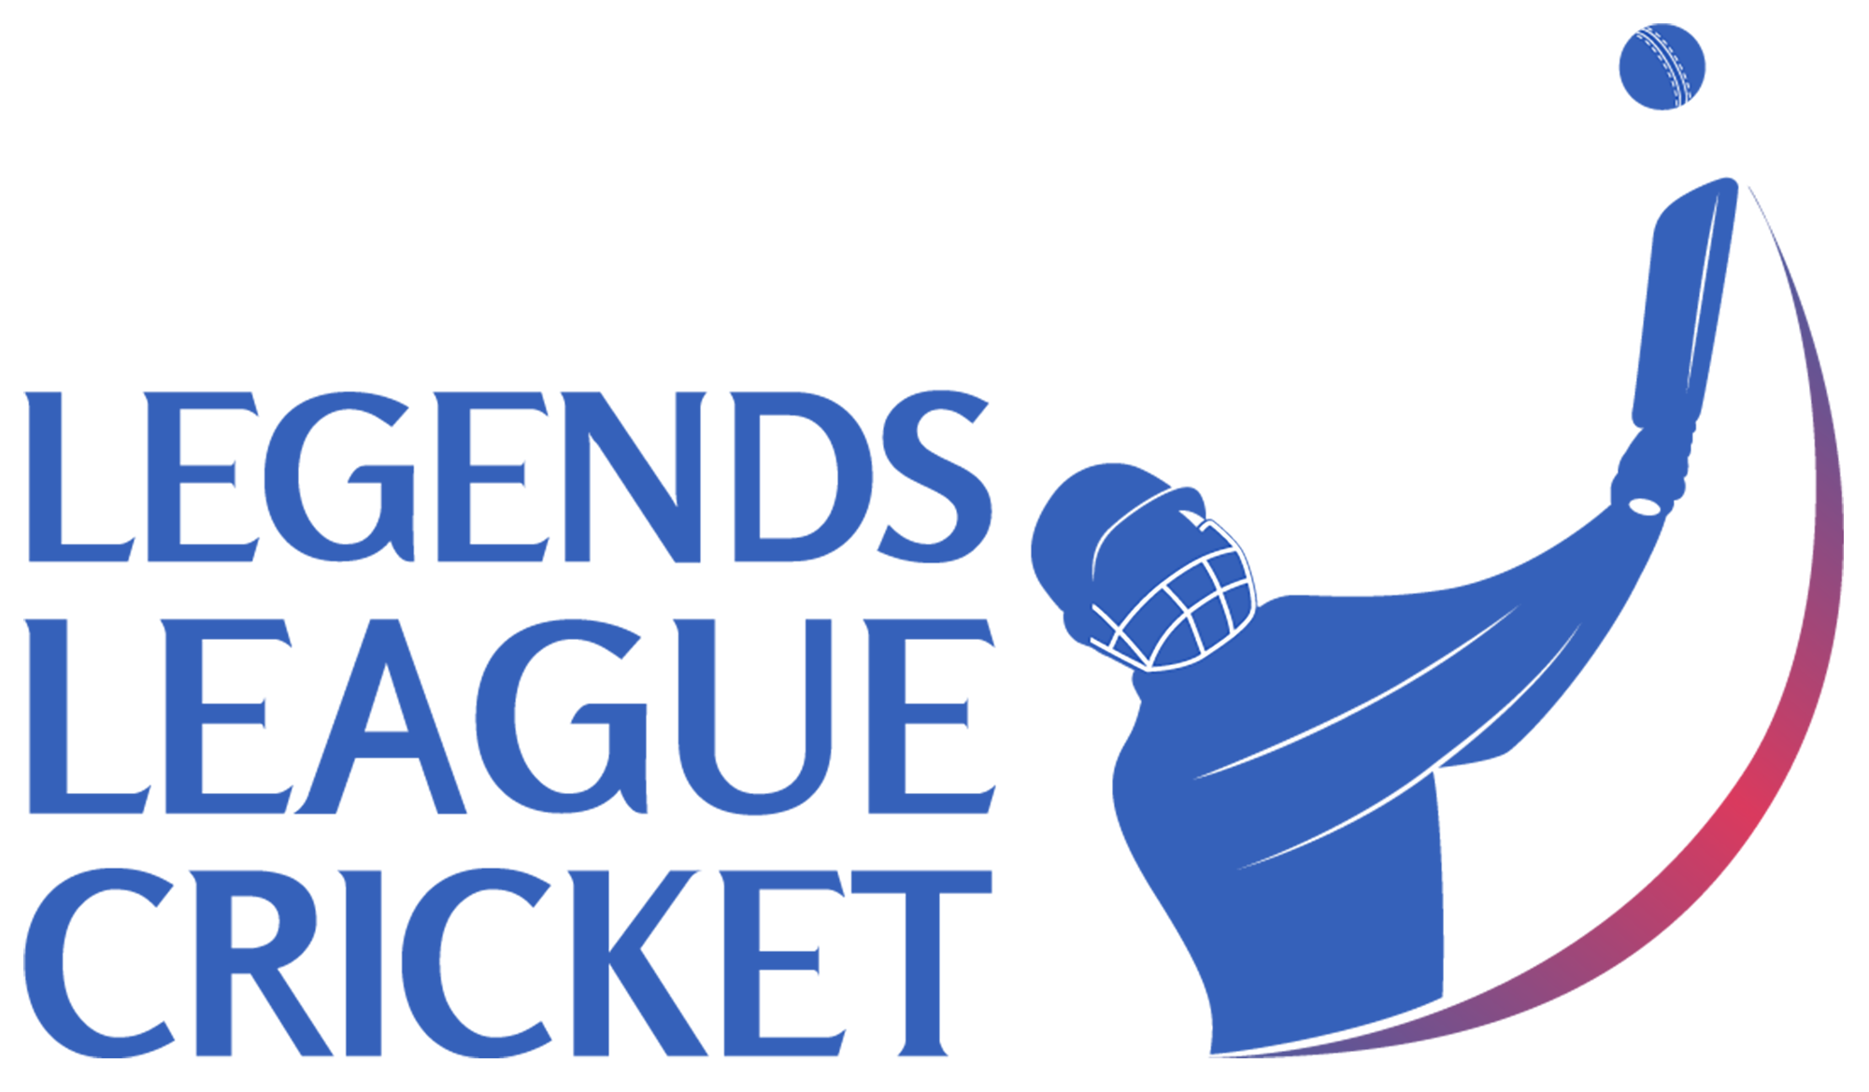

Eoin Morgan to play in Legends League Cricket, LLC Masters in Qatar

New Delhi, January 20, 2023: Legends League Cricket today announced that 2019 World Cup Winning England Captain will return to the Cricket field for the upcoming season LLC Master in Qatar. The format will have three teams Indian Maharajas, Asia Lions and World Giants. The series is played in Qatar from February 27 to March 08, 2023.
Post the success of second season in the four Franchise model, Legends League Cricket is ready with new season in Qatar. Some of the legends who have already confirmed include Gautam Gambhir, Irfan Pathan, Shahid Afridi, Shoaib Akhtar, Brett Lee, Shane Watson, Chris Gayle, and Lendl Simmons.
Morgan is the captain of 2019 ICC World Cup winning team. He is only the second player in cricketing history to score a century in one day international for two different countries.
Eion Morgan said, “I am excited to be part of the Legends League Masters and enjoy my game with the Legends. I have been following LLC games and really impressed by the commitment of players in the game.”
Raman Raheja, co-founder, and CEO Legends League Cricket said,” LLC is truly becoming the 2nd innings for the cricketers who retire after achieving success while playing for their countries or clubs. Eoin Joining us is a clear message to endorse the fact. We are here to celebrate cricket with legends.

